# Coder Information:Pass

Test Result: Success



# Case Mix Index (CMI) Analysis:Pass

Test Result: Success



# Case Mix Index (CMI) Comparison:Pass

Test Result: Success

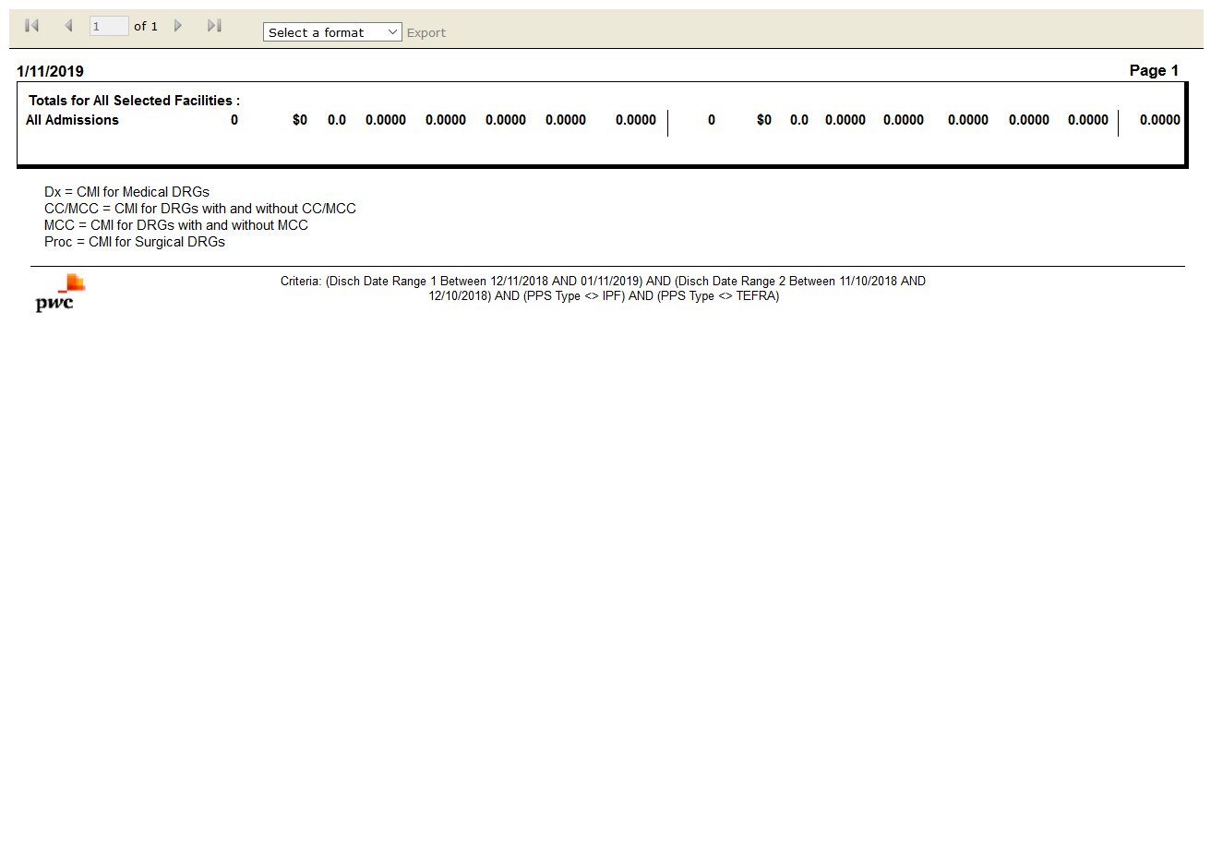

# Case-Mix by Payer by Month:Pass

Test Result: Success

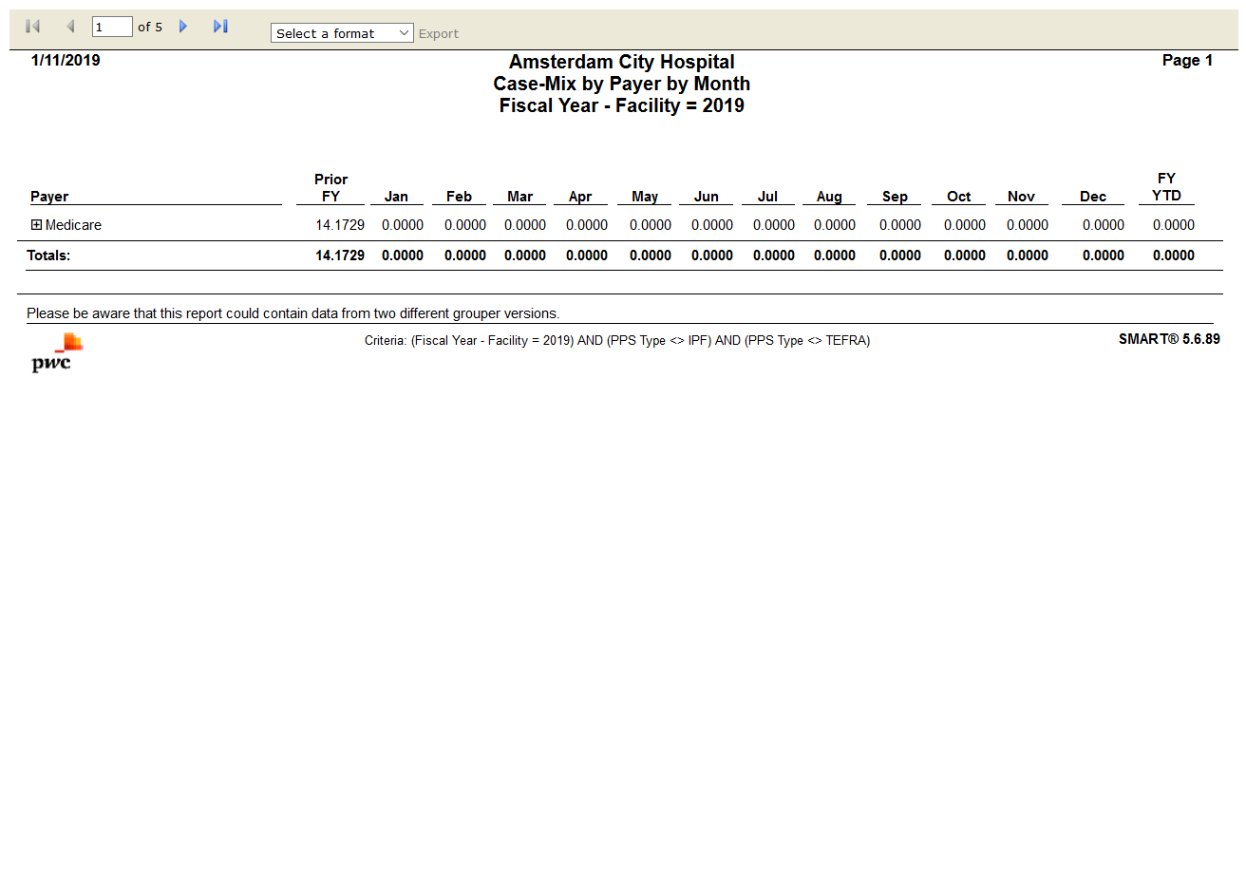

# Medicare Case-Mix by Month:Pass

Test Result: Success

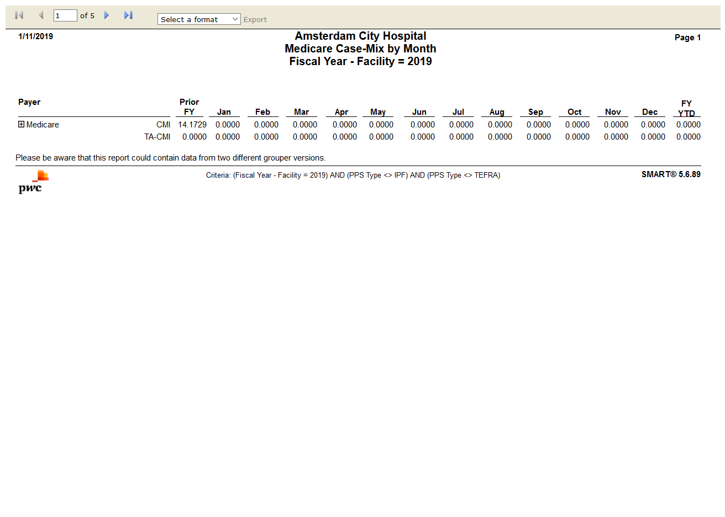

# Attending Physician Frequency by DRG:Pass

Test Result: Success

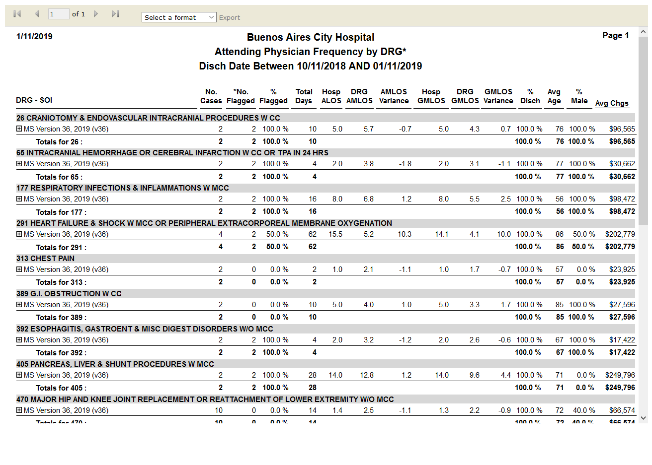

# Discharges by Grouper Version - DRG:Pass

Test Result: Success

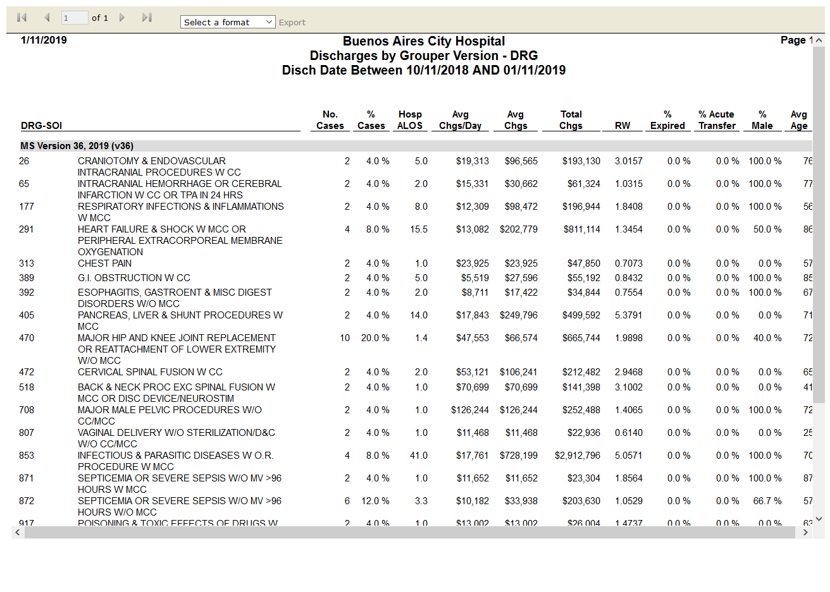

# DRG Change Condition Detail:Pass

Test Result: Success

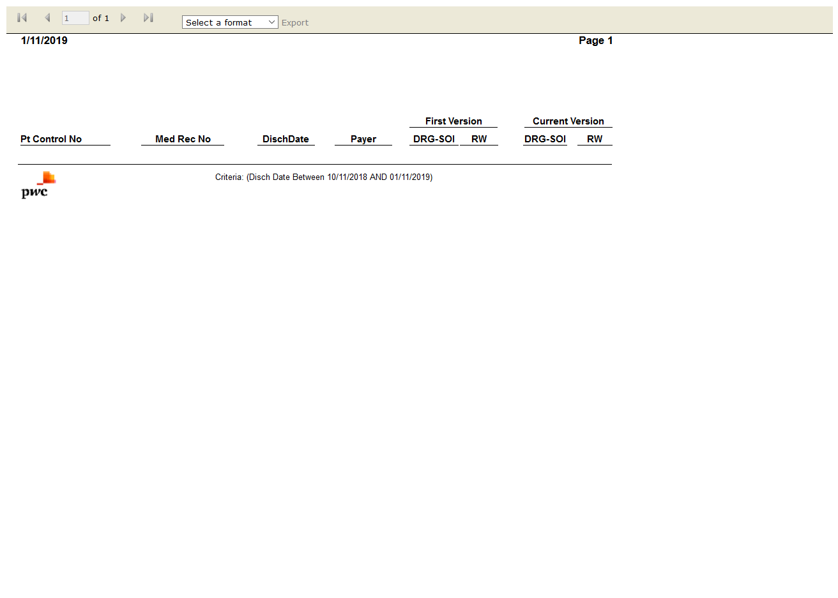

# DRG Change Impact:Pass

Test Result: Success

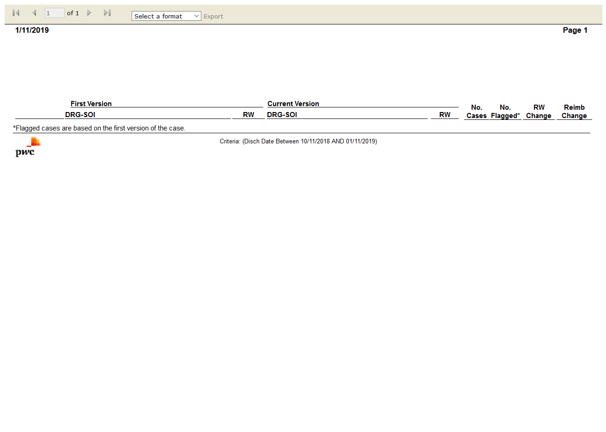

# DRG Clinical Profile:Pass

Test Result: Success

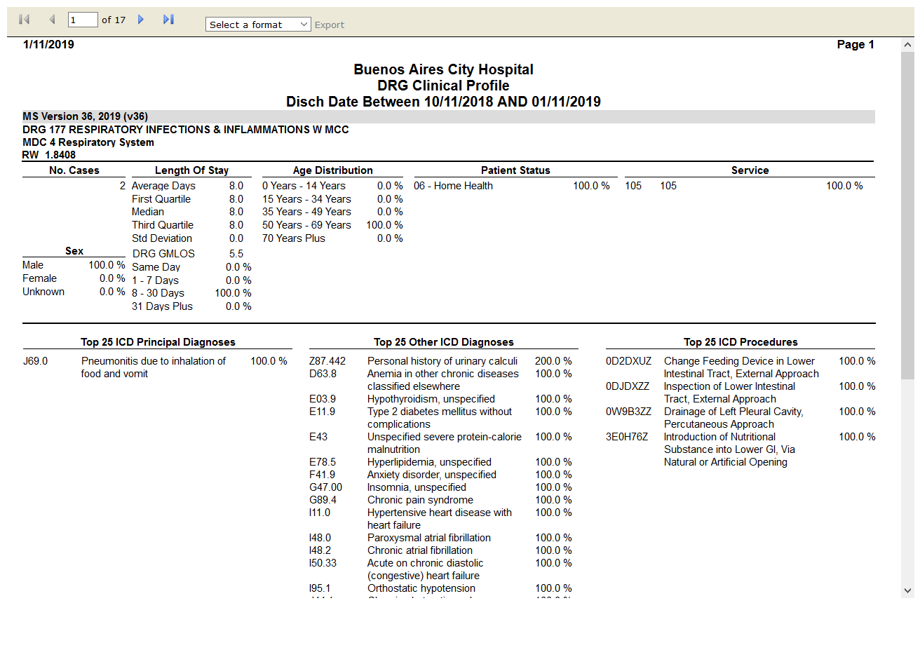

# DRG Contribution to CMI:Pass

Test Result: Success

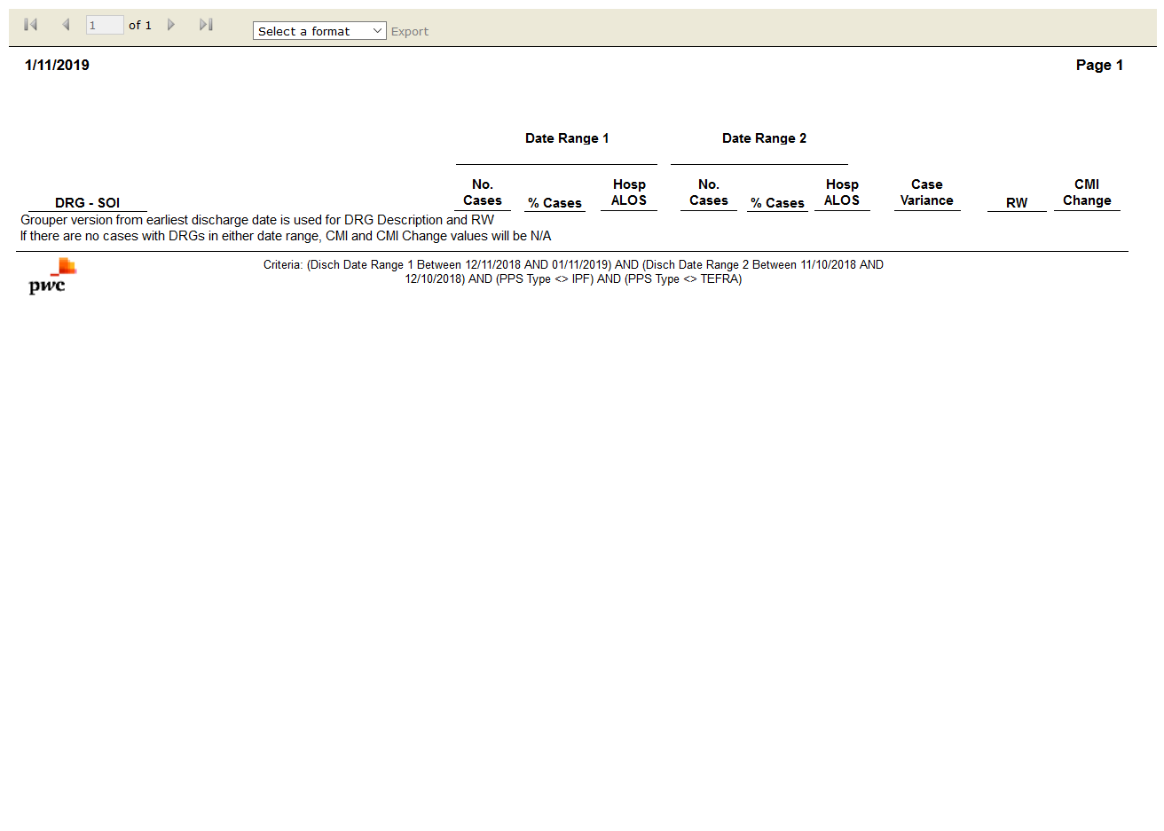

# Flag Management Setting Audit:Pass

Test Result: Success



# DRG Frequency:Pass

Test Result: Success

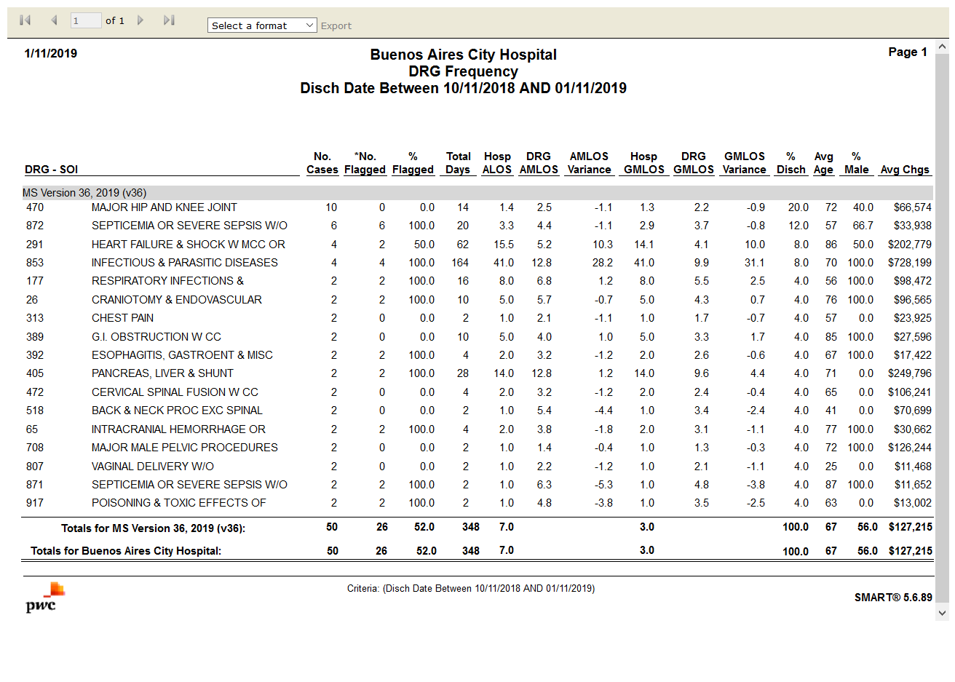

# DRG Illness Severity Score Comparison:Fail

Test Result: Message:

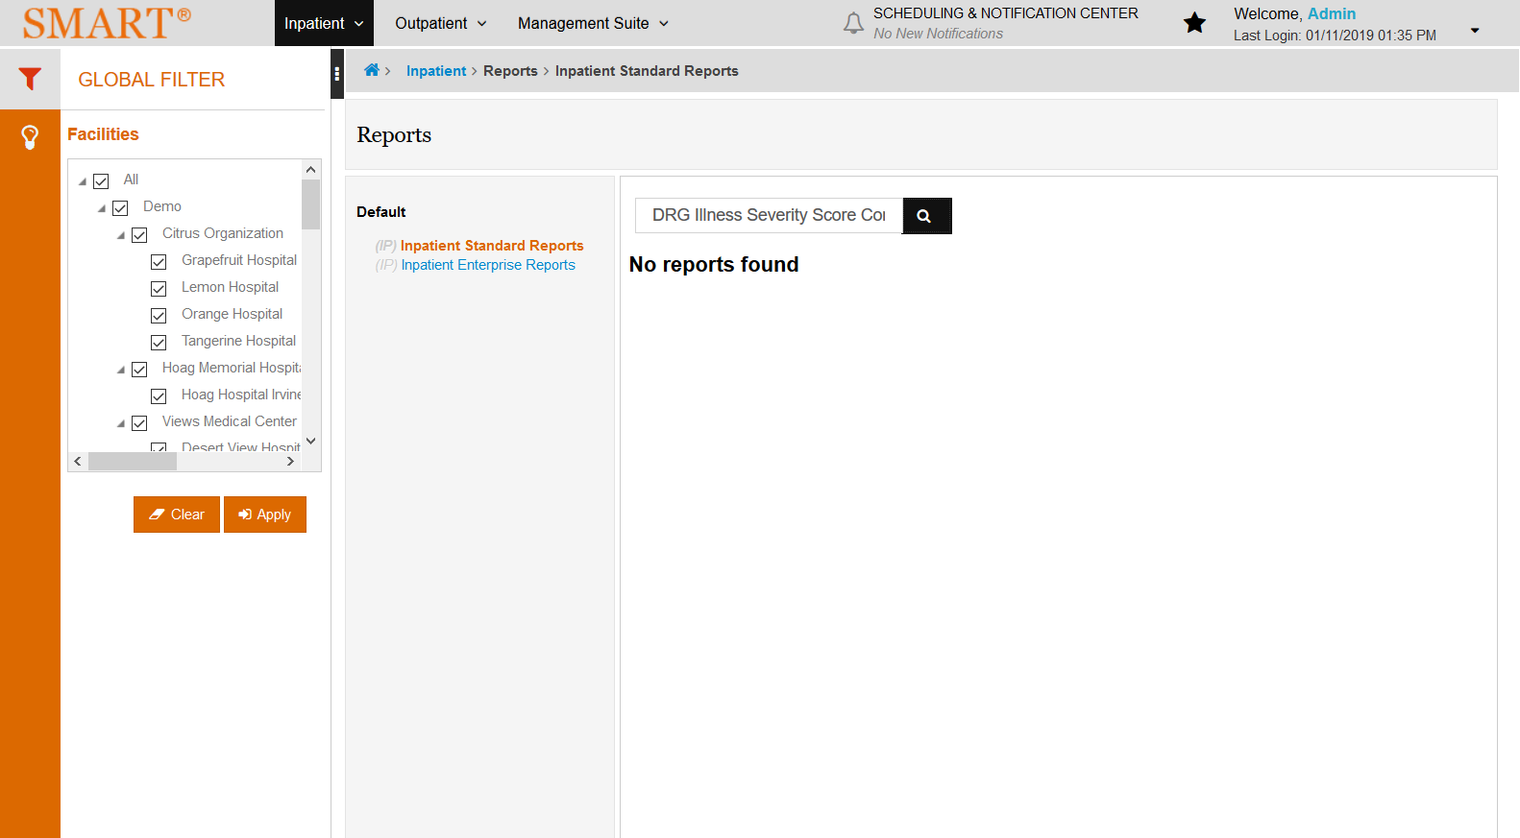

# DRG Summary by Grouper Version - MDC:Pass

Test Result: Success

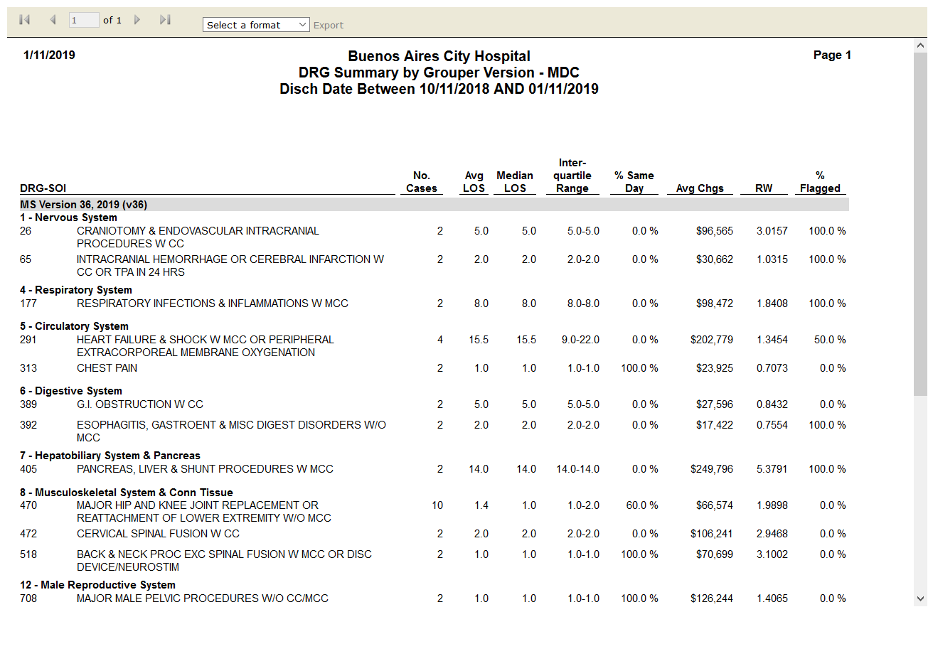

# Medicare Post-Acute Care (PAC) DRG Frequency:Pass

Test Result: Success

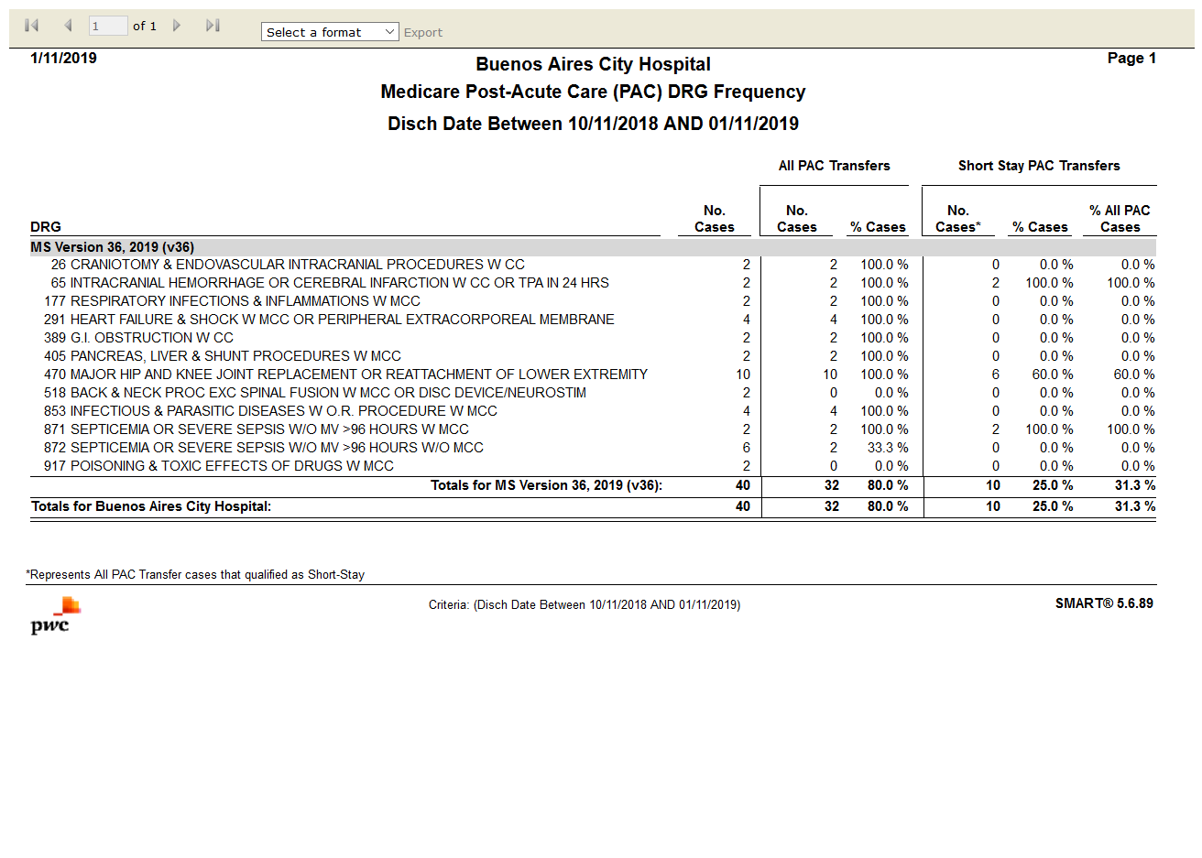

# Summary by Primary Flag:Pass

Test Result: Success

